LEONGATHA PRIMARY SCHOOL

Student Welfare
and Management

Behavioural
Management Policy

_____________________________________________________
Leongatha Primary School, Nerrena Rd, Leongatha 3953
Telephone: 5667 4600 Fax 5667 4699
Email: leongatha.ps@edumail.vic.gov.au

CONTENTS

Page Number
1 Behavioural Management Guidelines
2 LPS Student Code Conduct
3 LPS Values
4 Students’ Rights and Responsibilities
5 School Personnel Rights & Responsibilties
6 Parents’ Rights and Responsibilites
7 Positive Reinforcement
8 Classroom Management
9 Classroom Management Steps
10 Playground Management Steps
11 Bullying Management
12 Five Finger Plan
13 Bullying Policy
14 Interventions
15 Camps & Excursions

1
BEHAVIOURAL MANAGEMENT

GUIDELINES

This booklet provides clear guidelines as to the expectations, and procedures to be followed in relation to the behavioural management process at Leongatha Primary School.

There is a need for a fair and consistent approach to behavioural management at all levels throughout the school. This policy encompasses classroom management and procedures for dealing with breaches of the code of conduct in the school yard including bullying.

This booklet is designed to provide students, parents and teachers with an appreciation and understanding of strategies undertaken to ensure that the Leongatha Primary School
environment is safe and secure for all.

Communication between all parties is a crucial part of a fair and consistent approach to Student Welfare. Learning spaces are equipped with phones and computers and need to be readily used as part of our school’s policy.

In all Victorian schools corporal punishment is not permitted.

Our school believes that . . .

- students should develop self discipline, cooperative behaviour and a healthy level of self esteem.

- students are responsible for their own behaviour, language and actions.

- all members of our school community share the rights and responsibilities of encouraging positive behaviour.

- good behaviour needs to be encouraged through positive reinforcement and rewards.

- inappropriate behaviour needs to be actively discouraged.

- parents should discuss the Behavioural Management process with their children and actively support the school policy.

2

Learning for life

LPS
STUDENT CODE OF CONDUCT

Students have a right to
learn in an educational
environment which is safe
and free from harassment,
where both individual and
team qualities are valued.

3

Learning for life

AT
LEONGATHA PRIMARY SCHOOL

We value -

Tolerance and Understanding, Respect, Responsibility, Excellence, Inclusion, Honesty, Care and Trust.

4

STUDENTS’ RIGHTS

- Children have the right to be respected and cared for.

- Children have the right to work or play free from any form of harassment or bullying.

- Children have the right to be safe and secure at school.

- Children have the right to express themselves in an appropriate manner.

STUDENTS’ RESPONSIBILITIES

- Children must share the responsibility to keep Leongatha Primary School a happy and safe place for all.

- Children have the responsibility to obey and follow the school rules.
- Children have the responsibility to care about the school and its equipment.

- Children have the responsibility not to harass or bully any other person.

- Children have the responsibility to treat others with respect and not to interfere with the belongings of others.

5

SCHOOL PERSONNEL RIGHTS
(TEACHERS,TEACHER AIDES, OFFICE STAFF, CLEANERS & MAINTAINANCE STAFF)

- School Personnel have the right to be treated with respect.

- School Personnel have the right to carry out their professional duties in a safe and secure environment.

- School Personnel have the right to expect students to exercise self control.

- School Personnel have the right to expect children arrive at school clean, rested and healthy.

- School Personnel have the right to teach students who are punctual and regular in attendance.

SCHOOL PERSONNEL RESPONSIBILITIES

- School Personnel have the responsibility to care for the children in their charge.

- School Personnel have the responsibility to provide a stimulating classroom environment.

- School Personnel have the responsibility to communicate with parents when a need arises and to assist in developing strategies to deal with problems.

- School Personnel have the responsibility to provide a safe environment for all children.

6

PARENTS’ RIGHTS

- Parents have a right to expect their children to be taught effectively and be treated with care, understanding and respect.

- Parents have a right to meet with school personnel (by appointment).

- Parents have a right to have access to reports on their children’s progress and development.

- Parents have a right to be involved in school issues and to have their thoughts and opinions given serious consideration.

PARENTS’ RESPONSIBILITIES

- Parents have the responsibility to ensure that their children are sent to school clean, rested and healthy.

- Parents have the responsibility to encourage their children to develop a positive attitude towards school.

- Parents have the responsibility to ensure their children are punctual and regular in attendance.

- Parents have the responsibility to support their children at school.
- Parents have the responsibility to discuss any concerns, worries or opinions with school personnel in a courteous manner.

7
POSITIVE REINFORCEMENT

CLASSROOM RULES

- All teachers develop their class rules in consultation with students and display them prominently along with the resulting rewards and consequences.

CLASSROOM REWARDS

- Rewards for good behaviour are determined by the teacher and may include Merit Certificates, free time, bonus activities, stickers, etc.

- Well Done awards are presented each week at assembly. Teachers are to ensure that students receive at least two awards throughout the year.

PLAYGROUND RULES

- Follow instructions first time given.
- No bullying, rough play, swearing, teasing, name calling etc.
- Play in appropriate areas.
- Climbing trees, playing in gardens or climbing on roofs is not allowed.
- Unsupervised classrooms and corridors are out of bounds before school and at recess/lunch time.
- Use school equipment appropriately.

PLAYGROUND REWARDS

Yard duty teachers will carry reward tickets with them and when they notice a child ‘doing the right thing’, write the child’s name on the ticket.
Tickets will be collected and each Friday a name will be drawn out at assembly.
The winning child will be given a reward from the canteen at lunchtime.

The school has implemented a welfare program – ‘Friendly Schools and Families’ which aims at building well adjusted, tolerant and resilient children. It is part of the day to day teaching.

8
CLASSROOM MANAGEMENT

MANAGEMENT PLANS

There are set procedures to be followed when dealing with student misbehaviour. These procedures are to be followed when dealing with most of the student population at LPS. There are some students who require a varied approach to student management which is organised and approved by a member of the Principal team.

CONSEQUENCES FOR INAPPROPRIATE BEHAVIOUR

STEP 1 Child is given a clear command/direction for the inappropriate behaviour to
cease.

STEP 2 If inappropriate behaviour continues, record child’s name and notify them
accordingly.

STEP 3 If inappropriate behaviour continues, isolate the child in a nominated section of the classroom. Teacher speaks to the child at next break asking them to explain their behaviour and what they need to do to improve.
Child will negotiate with the teacher in order to return to normal class activities.

STEP 4 If inappropriate behaviour continues then time-out. A yellow card is sent with two responsible children who escort the offender to a teacher’s Time Out room where the child remains until the next break. Limited communication is to take place between the buddy teacher and the offender who is isolated in a discrete area of the room. If a student is uncooperative and will not go with the monitors contact the Principal team for assistance.

STEP 5 At the beginning of each break the child is to be escorted back to the class teacher by the buddy teacher. Child is then to negotiate with their teacher in order to return to normal class activities. If the classroom teacher believes it is necessary a note will be entered on the Compass program explaining the child’s behaviour.

STEP 6 The third time a child is given time-out within the span of a term will result in
in-school suspension for a period of time to be decided by the Principal or Assistant Principal. A meeting with the Parents, Teacher and Principal member will be organised.

Note: For repeat offenders a request will be made to interview the child in the presence of a parent. In School supervision requires the student to remain in the office area to complete work prepared by the teacher and has no contact
with other children. Play times and eating times are not consistent with the rest of the school.

9

CLASSROOM MANAGEMENT

RECORDING

A note will be recorded on the Compass chronicle system and if the classroom teacher feels it is necessary, this note will also be sent to the child’s parent through the Compass system.

Classwork missed is to be completed at home.
Records are to be recorded electronically.

SPECIALISTS

If a teacher’s Time Out grade is with a specialist then the specialist administers the established time out procedure.
If child requiring STEP 4 is with a specialist they are to be sent to a Time Out room in accordance to the Buddy Time Out Room.

MANAGEMENT PLANS

- In ‘severe’ cases of misbehaviour there may well be the need to move to STEP 6 earlier and maybe suspension immediately.
- If a child is violent or out of control the teacher is to send a monitor to the Team Leader with a red card, urgently requiring assistance to remove that child from their room.
In extreme cases send red card to office for the Assistant Principal or Principal.
- If a child’s behaviour is considered to be ‘regularly out of control’ the Principal or Assistant Principal will determine the appropriate action which may warrant a meeting with parents, loss of privileges, suspension or expulsion from school.
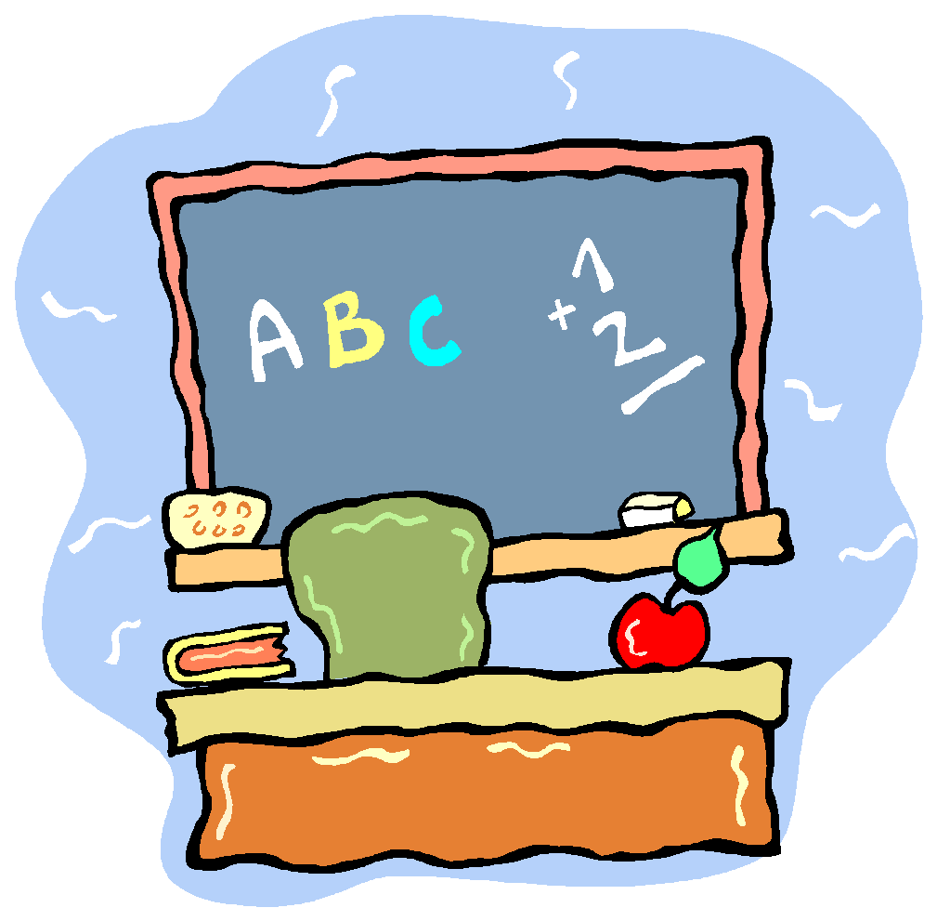

10

PLAYGROUND MANAGEMENT

CONSEQUENCES FOR INAPPROPRIATE BEHAVIOUR

STEP 1 For minor incidents child receives warning.
If a child receives a second warning on the same day they are to ‘shadow’ the
yard duty teacher. (To be recorded on the Compass chronicle.)

STEP 2 For more serious incidents name is recorded on the Compass chronicle and student shadows teacher. A Principal team member needs to be notified that day via email or phone message of any offence that warrents follow up.

STEP 3 Repeat offences (on same day) and/or serious misbehaviour will
result in immediate time out from the playground. At this point a Compass chronicle must be recorded (red alert warning) and child sent to the Assistant Principal/Principal.
Child to write explanation of their behaviour where appropriate.
The sheet will be sent home to be signed by parent and returned to the Assistant Principal.
Records to be entered electronically.

STEP 4 The third time a child receives a Playground warning with a chronicle entry within the span of a term will result in an Inschool Suspension.(the period of suspension will vary in accordance to the severity of the inappropriate behaviour). Parents will be notified and a meeting held to plan strategies needed for the student to resume regular school routine.

NOTES
- For severe cases of misbehaviour, students maybe given in school suspension, after school detention, or suspended immediately from school.
- At the completion of each term, Student Behavioural records will be reviewed by the Assistant Principal and if there are concerns with a child's behaviour, the parents may be notified of the repeated incidents of misconduct.
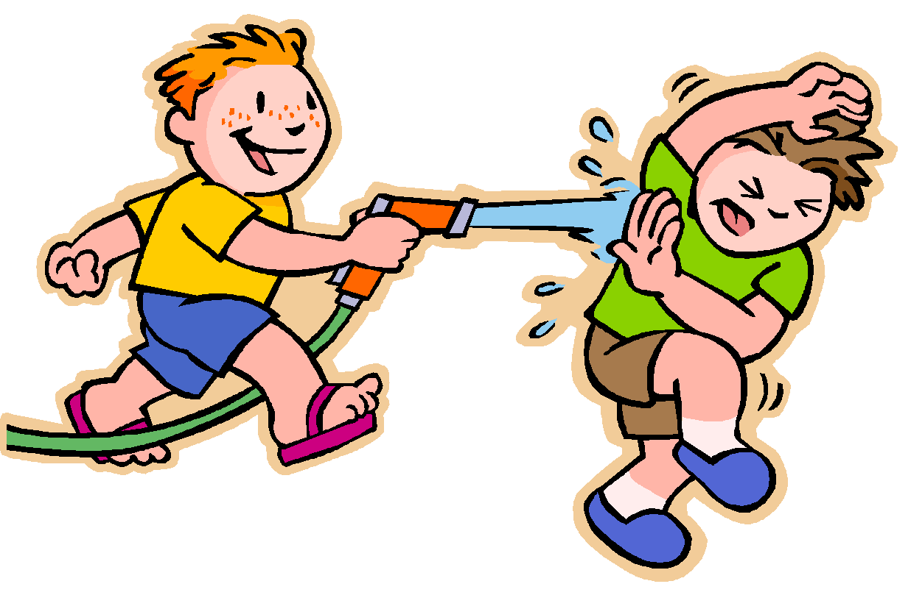
- If a child’s behaviour is considered to be ‘regularly out of control’ the Principal or Assistant Principal will determine the appropriate action which may warrant loss of privileges, suspension or expulsion from school.
A Behavioural Management plan may be put in place to assist the child in maintaining and improving their behaviour.

11

BULLYING MANAGEMENT

Bullying is never a good thing for bullies or victims.
Some people let bullying happen because they think:

- It's just a natural part of childhood
- I was bullied at school and it didn't do me any harm
- She'll/He'll just have to learn to stand up for herself/himself
- Tell him/her to hit back harder
- It's character building
- Sticks and stones may break my bones, but names will never hurt me.

At some stage in our lifetime we can all relate to one or more of
the above myths. We at Leongatha Primary School,
are determined to deal appropriately with
bullying.

12

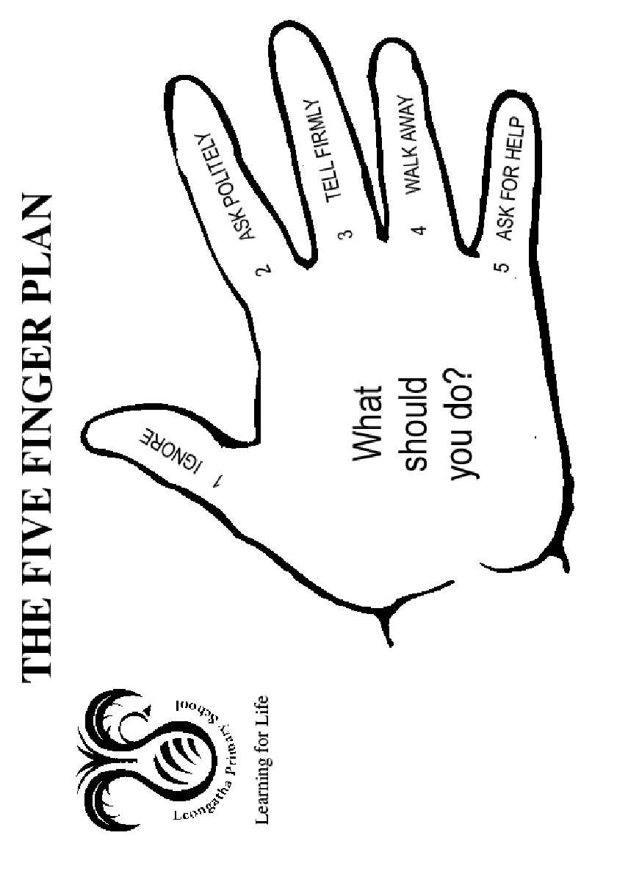
13
BULLYING POLICY

L Rationale:
- Leongatha
- Primary School will provide a positive culture where bullying is not accepted; in so doing, all will have the right of respect from others, the right to learn or to teach, a right to feel safe and secure in their school environment and a responsibility to ensure that this occurs.

Definition:
- Bullying is:-
- Physical Bullying – includes fighting, punching, shoving, gestures or invasion of personal space.
- Verbal Bullying – including name calling, offensive language, putting people down behind their backs, picking on people because of their race, gender or religious creed.
- Sexual Bullying – including touching or brushing against in a sexual manner, sexually oriented jokes, drawings, or writing about someone’s body, using rude names or commenting about someone’s morals, unwanted invitation of a sexual nature, asking questions about someone’s private life.
- Psychological Bullying – being made afraid of getting hurt, staring or giving someone mean looks or gestures.
- Exclusion – being ignored, left out on purpose or not allowed to join in.
- Cyber – inappropriate written or verbal contact made via telephone, computer or other technological devices.
Aims:
- To promote appropriate behaviours and create a safe and happy environment for all.
- To ensure that all reported incidents of bullying are followed up appropriately and that support is given to both victims and perpetrators.

Implementation:
- The focus should always be on bullying behaviours and not the child.
- Parents, teachers, students and the community will be aware of the school’s position on bullying.
- Leongatha Primary School promotes a restorative approach to bullying behaviour.
- Cyber Safety – Refer to eSmart Documentation developed 2014.

A. Primary Prevention:
- Five Finger Plan
- Documentation of Playground Incidents enteredin Yard Duty clipboard.
- Professional Development for Staff relating to bullying, harassment and proven counter measures. Resorative Practices.
- To provide programs, such as “Friendly Schools & Families” that promote resilience, life and social skills, assertiveness, conflict resolution and problem solving.
- A Welfare Survey will be administered annually.
- Each classroom teacher to clarify the school policy on bullying at the start of each year.
- The curriculum to include anti-bullying messages and strategies eg: “The Friendly Schools” and “No Blame Approach to Bullying” programs.
- Junior School Council, Peer Support and Peer Mediators staff and students to promote the philosophy of “No Put Downs”.
- Structured Activities available to students during lunch time eg Chess, board games, computers, basketball

14
B. Early Intervention
- Encourage children and staff reporting of bullying incidents involving themselves or others.
- Parents encouraged to contact school if they become aware of a problem.
- Public recognition and reward for positive behaviour and resolution of problems.

C. Intervention
- Both bullies and victims will be offered support and counselling as appropriate.
- Once identified each bully, victim and witness will be spoken with, and all incidents or allegations of bullying will be fully investigated and documented.
- If student bullying persists parents will be contacted and consequences implemented consistent with the school’s Student Code of Conduct and SWAM policy

D. Consequences
Consequences for students may involve:
- reinforcement of Restorative Practices and positive behaviours role play.
- inclusion of bullies and victims in Social Skills program.
- classroom Meetings
- exclusion from class.
- exclusion from yard.
- withdrawal of privileges.
- ongoing counselling from appropriate agency for both victim and bully
- Behavioural Management Plan
- school suspension.
- Expulsion

Welfare Survey:
An Annual Welfare Survey of students will be conducted to recognise the type of bullying, victims, teacher intervention and locations.

15
CAMPS AND EXCURSIONS

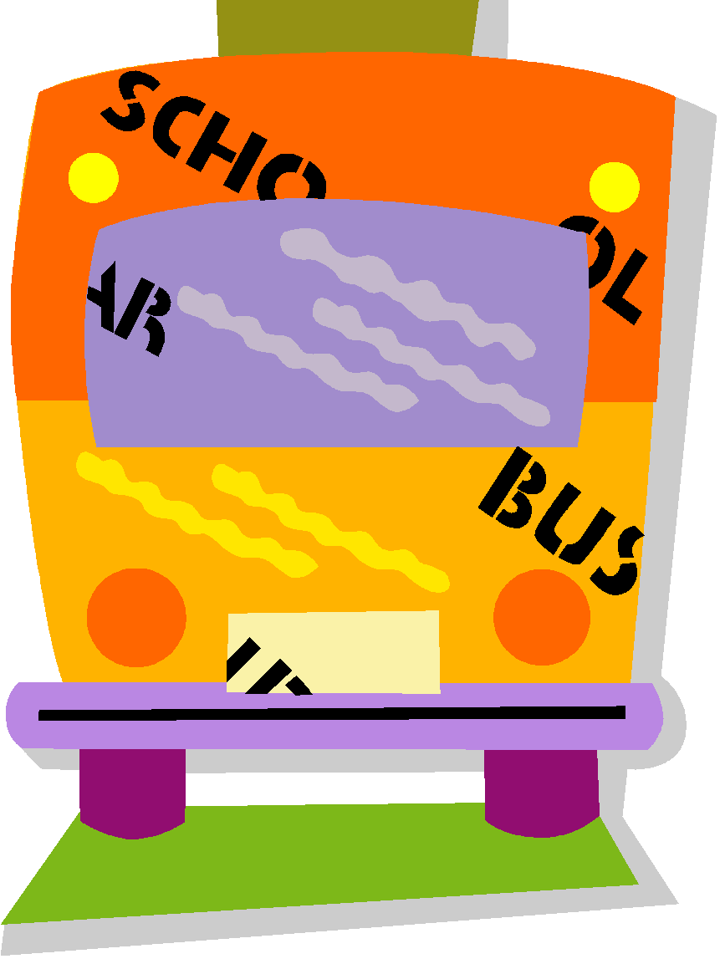

* Camps and Excursions are valued at LPS. It is our belief that every child should be given every opportunity to attend.

- It is considered a privilege, not a right for a child to attend a school excursion or camp. A child who regularly displays inappropriate behaviour whilst at school may not be seen to have earnt the right of attending the excursion or camp. Ongoing consultation with department leaders, Assistant Principal and Principal must be initiated before a final decision is made by the Principal. Parents will be notified of the reason(s) for exclusion.

- Children attending excursions or camps are expected to obey camp/school rules at all times. Before a school camp parents and children will be expected to sign a contract promising to abide by the camp/school rules.

- In the event of a child displaying severe or consistent inappropriate behaviour whilst on camp the parents will be contacted and be required to collect their child.

- The child will be expected to attend school in an alternate class until the end of camp.

